Assignment 5

**NAME**: Eniola Osabiya

Answer

**Screenshot:**

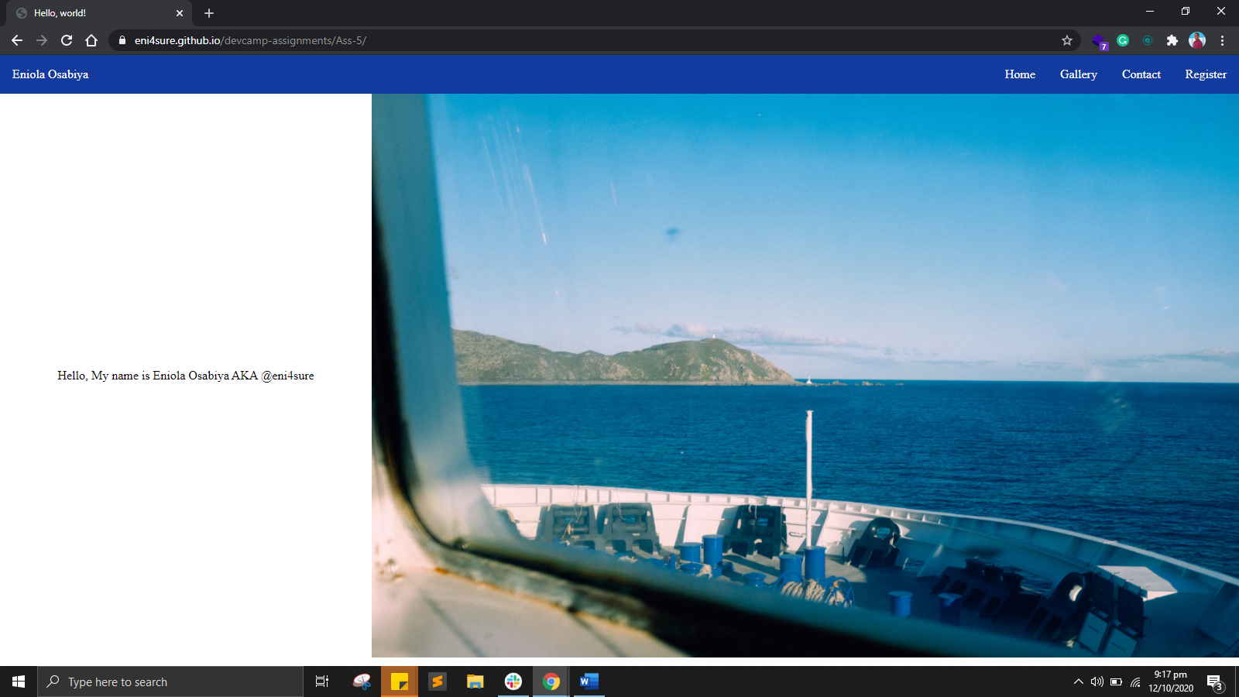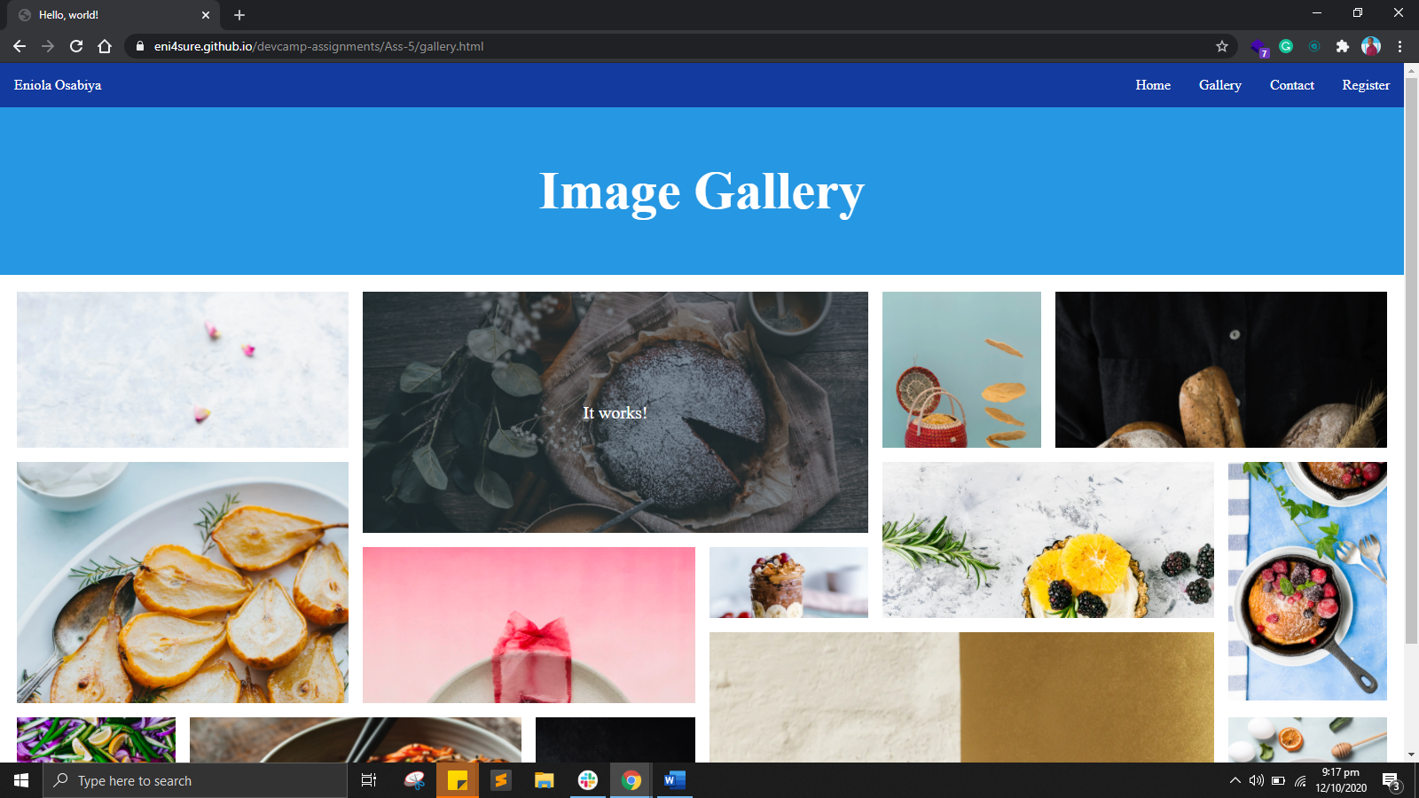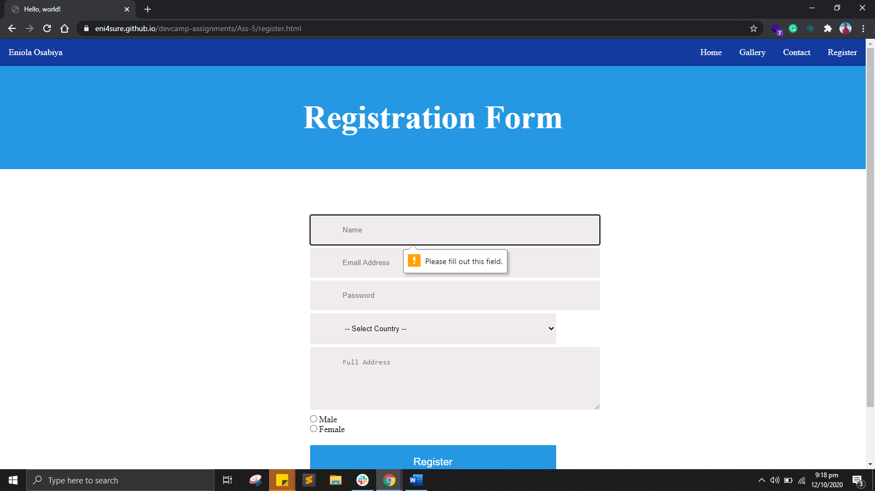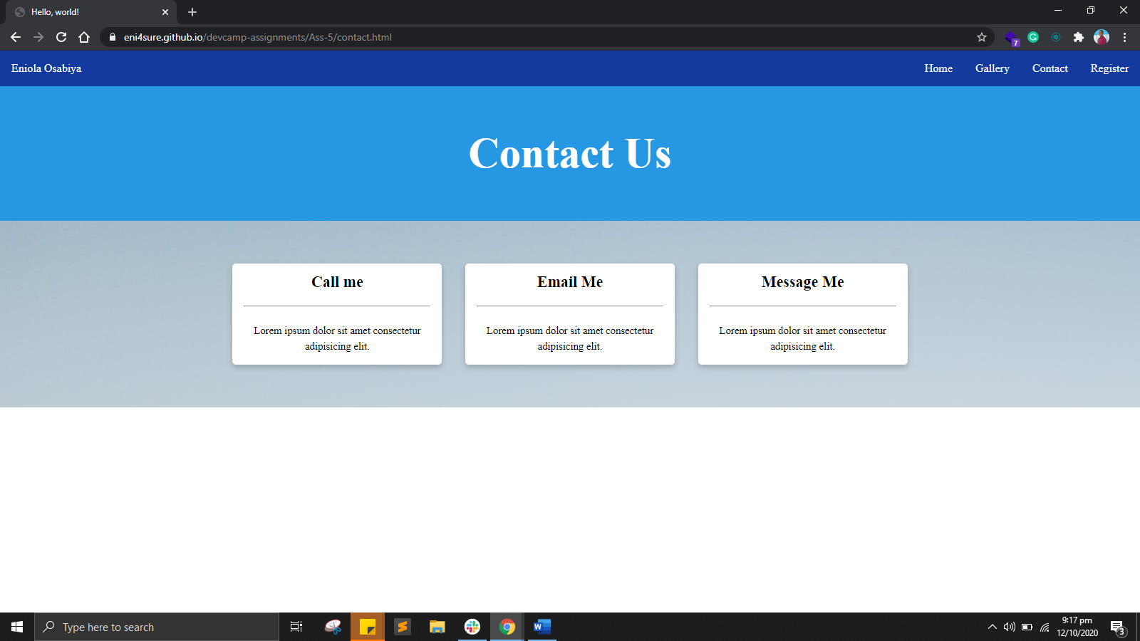

**Live url hosted:**

[**https://eni4sure.github.io/devcamp-assignments/Ass-5/**](https://eni4sure.github.io/devcamp-assignments/Ass-5/)

**Source code:**

**[https://github.com/eni4sure/devcamp-assignments/tree/](https://github.com/eni4sure/devcamp-assignments/tree/master/Ass-5)**

**[master/Ass-5/](https://github.com/eni4sure/devcamp-assignments/tree/master/Ass-5)**